ICT 1102 Introduction to Internet Technology

Information and Communication Technology

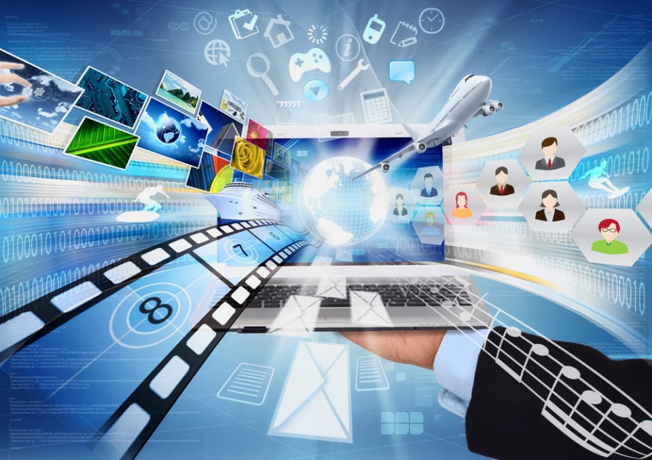

|  |  |  |  |  |  |  |
| --- | --- | --- | --- | --- | --- | --- |
|  | **Assignment 1** | | | | | |
| Module | | **ICT1102 INTRODUCTION TO INTERNET TECHNOLOGIES** | | | |
| Session | | **August 2021** | | | |
| Programme | | **DITN** | | | |
| Lecturer | | **ZURIANI HAYATI BINTI ABDULLAH** | | | |
| Coursework Type | | Individual Assignment | | | |
| Percentage | | 10% out of 100% | | | |
| Hand-out Date | | Week 6 | Due Date | Week 10 22 October 2021 | |
| **Students’ Declaration:** | | | | | |
| ***We declare that:***   * ***We understand what is meant by plagiarism*** * ***This assignment is all our own work and we have acknowledged any use of the published or unpublished works of other people.*** * ***We hold a copy of this assignment which we can produce if the original is lost or damaged*** | | | | | |
| **Learning Outcomes Assessed:** | | | | | |
| LO2 | Build web pages using HTML editor or web authoring tools. (P3,PLO3) | | | | |
| **Assessment Criteria** | | | **Total Marks** | | **Given Marks** |
| 1. | Quality of Web Content | | 10 | |  |
| 2. | Image / Multimedia Sources/ sound/ video | | 10 | |  |
| 3. | Citations/references(reliable sources) | | 5 | |  |
| 4. | Grammar & Spelling | | 5 | |  |
| 5. | Links (relative links and absolute links)  Anchors and links to anchors within the same page | | 10 | |  |
| 6. | Appearance / Colour management / Interface design | | 10 | |  |
| ***Sub-total (50%)*** | | | | |  |
|  | | | **100%** | |  |
|  | | | **Penalty** | |  |
| Received by: Date: | | | **Final Mark (10%)** | |  |
| **Lecturer’s Comments** | | | | | |
|  | | | | | |
| **Penalty for late submission:** | | | | | |
| 1 day – minus 20% of total mark awarded; 2 days – minus 50% of total mark awarded; 3 days – 0 mark for this piece of coursework | | | | | |

**Description of Assignment 1:**

This is an individual assignment. You are required to **research on latest issues on internet technology**.

You are required to build a simple web page and present your findings in that web page.

1. Use the search engine of your choice to research on latest issues/trends on internet technology. Some examples of topics are:
   1. Cybersecurity for online transaction
   2. Privacy rights of Internet users
   3. Internet and Web Threats
   4. Search engine algorithm trends
   5. Hashtags marketing examples
   6. Deep web criminal activity
   7. Microblogging
   8. Phishing and Spoofing
   9. Massive Open Online Courses
   10. User Generated Content Tools
   11. Current Virus, Worm and Trojan Horse Risks
   12. Analyzing personal security threats
   13. Comparing and Contrasting User features of Popular Web Browsers
   14. Investigating Web Browser Features
   15. Exploring Mobile Web Browsers
   16. You can propose you own topic. E-mail your choice of topic to Ms. Zuriani for approval. Each student is expected to write on a different topic.
2. Give your **thoughts or opinion** on your chosen topic (open-ended).
3. Remember to **cite** your sources correctly. Use Harvard Referencing System.

4. Final step, develop a simple web page by using HTML editor/ Notepad

**There are a few requirements that you should follow:**

* The language used in the blog must be in **ENGLISH.**
* **Use good taste** in all aspects of your web page, including any and all comments you wish to make. Otherwise, your assignment will not be accepted.
* Proper English usage, **spelling**, paragraph and sentence construction, **grammar** etc. must be used. Failure to do so will result in loss of points.
* The blog interface design and contents will be assessed.
* Softcopy for web page content is required.
* Submission should consist of the following: (recommended)
  + Assignment Cover Sheet
  + Print out of your web page.
* Students must acknowledge in the assignment if they have used someone else’s ideas or words by including proper referencing.
* You may want to use this Harvard Generator: <http://www.harvardgenerator.com/>
* All submitted work must be signed by the lecturer, as the proof of receipt of the coursework. Any work not signed will be treated as late submission.
* This assignment MUST be submitted on or before the given due date.

**End of Assignment 1**

Table of contents

1.Introduction………………………………………………………. 5

2.What is Information and Communication Tech……6

3.Component of ICT…………………………………………….7-8

3.1 Cloud computing…………………………………………….…9

3.2 Software …………………………………………………………10

3.3 Hardware………………………………………………………11

3.4 Digital transections………………………………………….12

3.5 Digital data………………………………………………………13

3.6 Internet access……………………………………………….14

4. Advantages and Disadvantages of using Information and Communication Tech………………15-16

5.Conclusion……………………………………………………….17

6.Reference………………………………………………………….18

1. Introduction

I (Tan Xuan Hong) decided to choose the topic Information and Communication tech in this individual assignment for the course ICT1102.This report will explain the topic Information and Communication tech as well. In this globalization era technology of Information and communication were used in network domain and specific software. Many technologies can’t develop without the Information and Communication tech. Our life is inseparable without Information and Communication tech in the software that we always use for communication for example messenger, WhatsApp, WeChat, Line.

What is the Information and Communication tech?

Information and Communication Technologies is a broader term for Information Technology, which refers to all communication technologies, including the internet, wireless networks, cell phones, computers, software, middleware, videoconferencing, social networking, and other media applications and services enabling users to access, retrieve, store, transmit, and manipulate information in a digital form.

Although ICT is often considered an extended synonym for information technology (IT), its scope is, in some ways, broader. ICT is often used to describe the convergence of several technologies, and the use of common transmission lines carrying very diverse data and communication types and formats.

Component of ICT

Components of an ICT system ICT encompasses both the internet-enabled sphere as well as the mobile one powered by wireless networks. It also includes antiquated technologies, such as landline telephones, radio and television broadcast -- all of which are still widely used today alongside cutting-edge ICT pieces such as artificial intelligence and robotics.

ICT is sometimes used synonymously with IT (for information technology); however, ICT is generally used to represent a broader, more comprehensive list of all components related to computer and digital technologies than IT.

The list of ICT components is exhaustive, and it continues to grow. Some components, such as computers and telephones, have existed for decades. Others, such as smartphones, digital TVs and robots, are more recent entries.

ICT commonly means more than its list of components, though. It also encompasses the application of all those various components. It's here that the real potential, power and danger of ICT can be found.

### •Cloud computing

-The term is generally used to describe data centers available to many users over the Internet. Large clouds, predominant today, often have functions distributed over multiple locations from central servers. If the connection to the user is relatively close, it may be designated an edge server. Clouds may be limited to a single organization (enterprise clouds), be available to many organizations (public cloud) or a combination of both (hybrid cloud). For example the largest public cloud is Amazon AWS.

### •Software

- Software is a set of instructions, data or programs used to operate computers and execute specific tasks. Opposite of hardware, which describes the physical aspects of a computer, software is a generic term used to refer to applications, scripts and programs that run on a device. Software can be thought of as the variable part of a computer and hardware the invariable part. Software is often divided into application software, or user downloaded programs that fulfil a want or need, and system software, which includes operating systems and any program that supports application software.

### •Hardware

-in the context of technology, refers to the physical elements that make up a computer or electronic system and everything else involved that is physically tangible. This includes the monitor, hard drive, memory and the CPU. Hardware works hand-in-hand with firmware and software to make a computer function. Hardware is only one part of a computer system; there is also firmware, which is embedded into the hardware and directly controls it.

### •Digital Transactions

-Digital Transactiona can be broadly defined as online or automated transactions that take place between people and organizations—without the use of paper. Digital transactions save time and money, resulting in a better bottom line. Customer experiences are also enhanced (think of the convenience of eSigning versus having to print a contract, sign it, and then return it by mail or fax). And digital transactions improve tracking capabilities—which helps reduce errors.

### •Digital Data

-Digital data is data that represents other forms of data using specific machine language systems that can be interpreted by various technologies. The most fundamental of these systems is a binary system, which simply stores complex audio, video or text information in a series of binary characters, traditionally ones and zeros, or «on» and «off» values.

### •Internet access

The internet access is the process of connecting to the internet using personal computers, laptops or mobile devices by users or enterprises. Internet access is subject to data signalling rates and users could be connected at different internet speeds. Internet access enables individuals or organizations to avail internet services/web-based services. The internet began to gain popularity with dial-up internet access. In a relatively short time, internet access technologies changed, providing faster and more reliable options. Currently, broadband technologies such as cable internet and ADSL are the most widely used methods for internet access. The speed, cost, reliability and availability of internet access depends on the region, internet service provider and type of connection.

Disadvantages and advantages of Information and Communication Technology

Advantages

-Greater efficiency throughout the school.

-Communication channels are increased through email, discussion groups and chat rooms.

-Regular use of ICT across different curriculum subjects can have a beneficial motivational influence on students’ learning.

-Improved access to education, for example distance learning and on-line tutorials. New ways of learning, for example interactive multi-media and virtual reality. New job opportunities, for example flexible and mobile working, virtual offices and jobs in the communications industry.

-ICT can be used to help people overcome disabilities. For example screen magnification or screen reading software enables partially sighted or blind people to work with ordinary text rather than Braille.

Disadvantages

-Job loss: One of the largest negative effects of ICT can be the loss of a person’s job. This has both economic consequences, loss of income, and social consequences, loss of status and self-esteem. Job losses may occur for several reasons, including Manual operations being replaced by automation. For example, robots replacing people on an assembly line. Job export. For example, Data processing work being sent to other countries where operating costs are lower. Multiple workers being replaced by a smaller number who can do the same amount of work. For example, A worker on a supermarket checkout can serve more customers per hour if a bar-code scanner linked to a computerized till is used to detect goods instead of the worker having to enter the item and price manually.

-Reduced personal interaction: Being able to work from home is usually regarded as being a positive effect of using ICT, but there can be negative aspects as well. Most people need some form of social interaction in their daily lives and if they do not get the chance to meet and talk with other people, they may feel isolated and unhappy.

-Reduced physical activity: A third negative effect of ICT is that users may adopt a more sedentary lifestyle. This can lead to health problems such as obesity, heart disease, and diabetes. Many countries have workplace regulations to prevent problems such as repetitive strain injury or eyestrain, but lack of physical exercise is rarely addressed as a specific health hazard.

4.conclusion

As a conclusion, we know the information and communication always update so, we must always update our information in technology to avoid eliminated by the times and we can use the newest information in our future to bring benefits to other. In addition, we know Information and Communication Technology give us many advantages and disadvantages. So, we also need to remind ourselves do not abusing technology in order to achieve own purpose. Technology is for convenience not for bring harm to the world.

Reference

-<https://searchcio.techtarget.com/definition/ICT-information-and-communications-technology-or-technologies>

-<http://aims.fao.org/information-and-communication-technologies-ict>

<https://cynthia123web.wordpress.com/2016/09/26/advantages-and-disadvantages-of-information-and-communication-technology-ict/>

<https://en.wikipedia.org/wiki/Information_and_communications_technology>

<http://ict-adv-disadv.blogspot.com/>